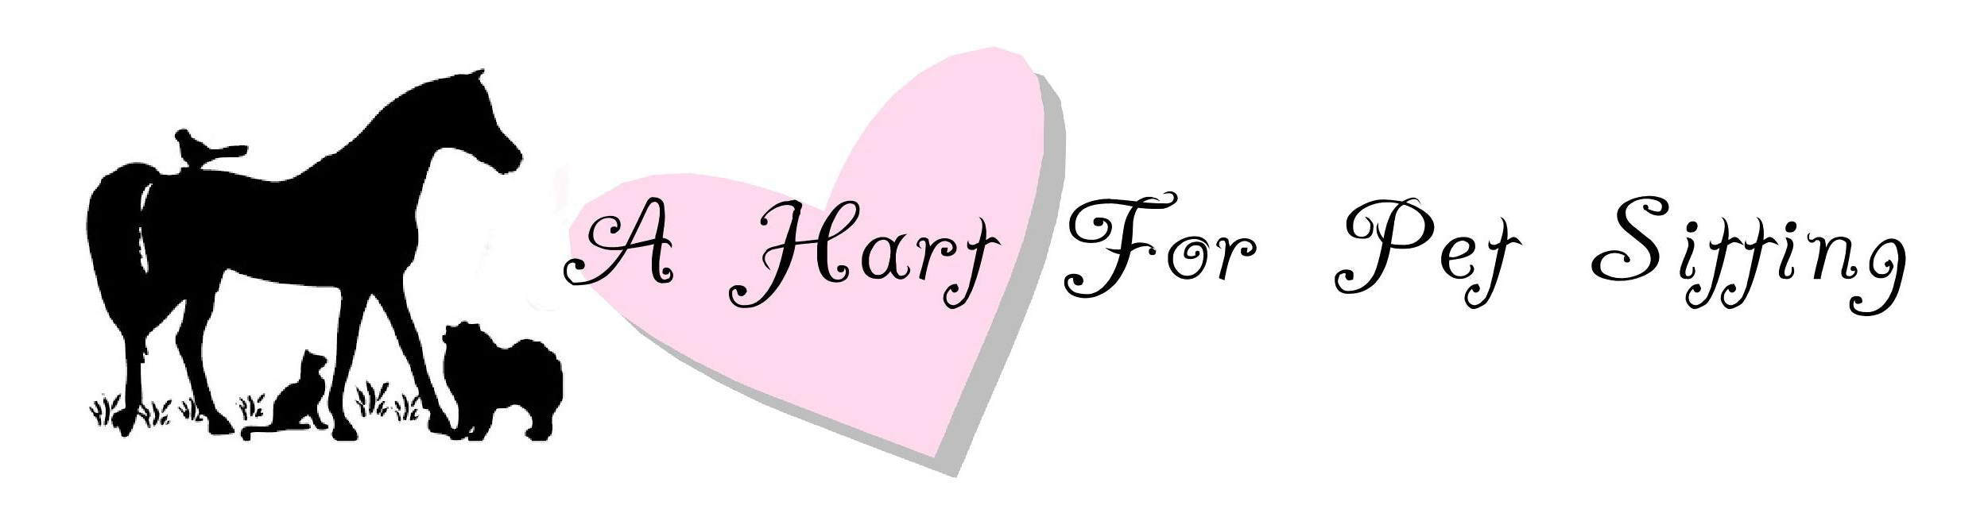

Agreement

I authorize Amy Hart/A Hart For Pet Sitting to obtain any emergency veterinary care that may be necessary during the time spent with my pet. I accept responsibility for any charges related to this emergency care. I also authorize Amy Hart/A Hart For Pet Sitting
to utilize an alternative veterinarian in the event my regular veterinarian is unavailable. Every effort will be made to contact the owner prior to obtaining emergency care.

Amy Hart/A Hart For Pet Sitting accepts no responsibility for security of the premises or loss if other individuals have access to the home during the term of this agreement. Only Amy Hart/A Hart For Pet Sitting will perform pet care during all assignments unless prearranged with client.

I agree to reimburse Amy Hart/A Hart For Pet Sitting for any additional fees for providing emergency care, as well as any expenses incurred for unexpected visits, transportation, housing, food or supplies.

Amy Hart/A Hart For Pet Sitting agrees to provide the services stated in this agreement in a reliable, caring and trustworthy manner. In consideration of these services and as an express condition thereof, the client expressly waives and relinquishes any and all claims against Amy Hart/A Hart For Pet Sitting, except those arising from negligence or willful misconduct on the part of the Amy Hart/A Hart for Pet Sitting. Amy Hart/A Hart For Pet Sitting is not responsible for any damage(s) incurred by pet(s) escaping because of faulty leash/collar or a collar that is not properly fitting and/or functioning. Client agrees to notify Amy Hart/A Hart For Pet Sitting of any concerns within 24 hours from completion of service, of any complaints.

Amy Hart/A Hart For Pet Sitting will not be liable for the injury, disappearance, death, or fines of any pet(s) with unsupervised access to the outdoors.

Client will be responsible for all medical expenses and damages resulting from an injury to the pet sitter by the pet(s). Customer agrees to indemnify and hold harmless Amy Hart/A Hart For Pet Sitting in the event of a claim by any person(s) injured by the pet(s).

This agreement is valid for all future visits until a new agreement is signed. Amy Hart/A Hart For Pet Sitting reserves the right to terminate this agreement at any time, at its sole discretion; likewise, client may terminate this agreement at any time. Any client that chooses to terminate this agreement must do so in writing. There is no term of contract for daily dog walking.

It is expressly understood that Amy Hart/A Hart For Pet Sitting shall not be held responsible for any damage(s) to client’s property, or that of others, caused by client’s pet(s) during the period in which they are in its care. Client has advised Amy Hart/A Hart For Pet Sitting of all situations, which will relieve it of liability for damage(s).

Fees are earned upon acceptance of pet sitting reservations. Clients must give a minimum of 24 hours notice to receive credit against future walks. Credit against future sitting may be given, at the discretion of Amy Hart/A Hart For Pet Sitting. A Fee of $25.00 will apply to all returned checks. Payment is due within 15 days from the last day of care. Overdue accounts are subject to a service charge of 2% per month. Client is responsible for all costs of collection.

I have read the terms of this agreement and confirm the accuracy of the information provided.

_________________________________________________________________ ___________________________________
Client Signature Date

_________________________________________________________________ ___________________________________
Client Signature Date

